Name: B. Ganga Niranjan
Reg No:192424041
Date:08-01-2026
Course Code:DSA0412
11. Scenario :
You are a data scientist working for a company that sells products online. You have
been tasked with creating a simple plot to show the sales of a product over time.
Question:
1. Write code to create a simple line plot in Python using Matplotlib to predict sales happened in a
month?
2. Write code to create a scatter plot in Python using Matplotlib to predict sales happened in a
month?
3. Develop a Python program to create a bar plot of the monthly sales data.
Code 1:
import matplotlib.pyplot as plt
months = [1, 2, 3, 4, 5, 6]
sales = [12000, 15000, 14000, 17000, 16000, 18000]
plt.plot(months, sales, marker='o')
plt.xlabel("Month")
plt.ylabel("Sales")
plt.title("Monthly Sales Line Plot")
plt.show()
Output 1:
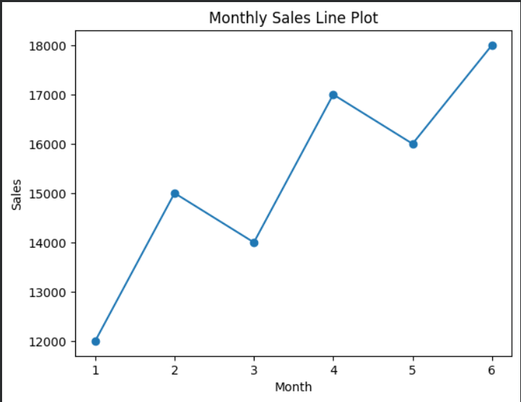
Code 2:
import matplotlib.pyplot as plt
plt.scatter(months, sales)
plt.xlabel("Month")
plt.ylabel("Sales")
plt.title("Monthly Sales Scatter Plot")
plt.show()
Output 2:
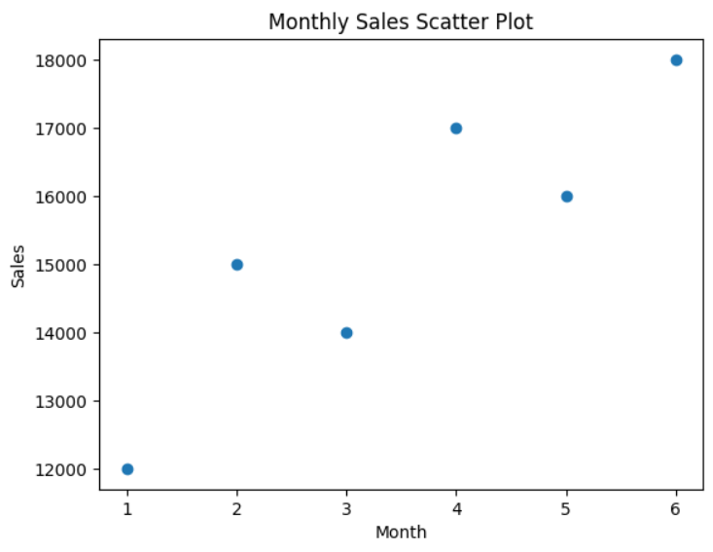
Code 3:
import matplotlib.pyplot as plt
plt.bar(months, sales)
plt.xlabel("Month")
plt.ylabel("Sales")
plt.title("Monthly Sales Bar Plot")
plt.show()
Out put 3: 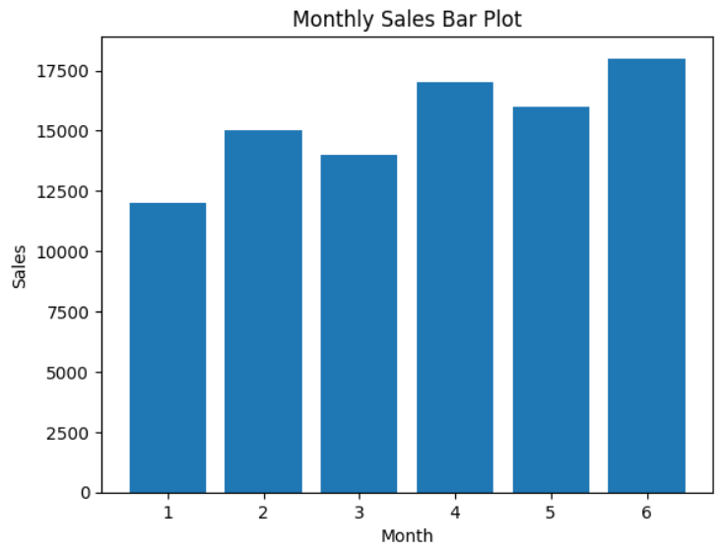
12. Scenario:
You are working on a data analysis project that involves analyzing the monthly temperature and rainfall data for a city. You have a dataset containing the monthly temperature and rainfall values for each month of a year. Your task is to develop a Python program that generates line plots and scatter plots to visualize the temperature and rainfall data.
Question:
1. Develop a Python program to create a line plot of the monthly temperature data.
2: Develop a Python program to create a scatter plot of the monthly rainfall data.
Code 1:
import matplotlib.pyplot as plt

months = ["Jan", "Feb", "Mar", "Apr", "May", "Jun",
"Jul", "Aug", "Sep", "Oct", "Nov", "Dec"]

temperature = [25, 27, 30, 33, 35, 34, 32, 31, 30, 28, 26, 25]

plt.plot(months, temperature, marker='o')
plt.xlabel("Month")
plt.ylabel("Temperature (°C)")
plt.title("Monthly Temperature Line Plot")
plt.show()
output 1:
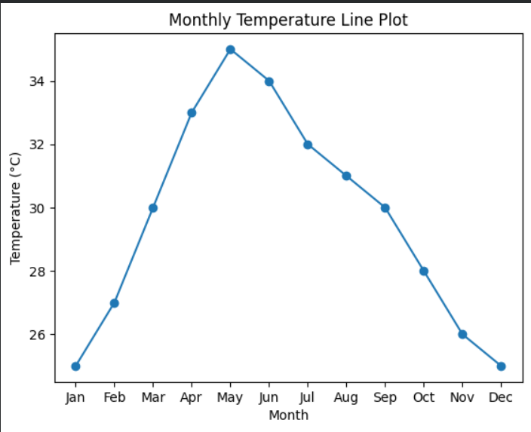
code 2:
import matplotlib.pyplot as plt
rainfall = [20, 25, 40, 60, 80, 120, 150, 140, 100, 60, 40, 30]
plt.scatter(months, rainfall)
plt.xlabel("Month")
plt.ylabel("Rainfall (mm)")
plt.title("Monthly Rainfall Scatter Plot")
plt.show()
Output 2:
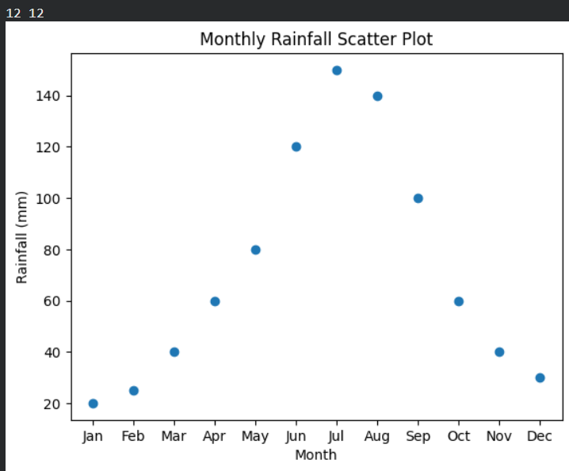
13. Scenario:
You are working on a text analysis project and need to determine the frequency
distribution of words in a given text document. You have a text document named "sample_text.txt"
containing a paragraph of text. Your task is to develop a Python program that reads the text
document, processes the text, and generates a frequency distribution of the words.
Question:
How would you develop a Python program to calculate the frequency distribution of
words in a text document?
Code:
# Create the text file
with open("sample_text.txt", "w") as file:
file.write("Data science is important. Data analysis is a key part of data science.")
with open("sample_text.txt", "r") as file:
text = file.read()
text = text.lower()
import string
for char in string.punctuation:
text = text.replace(char, "")
words = text.split()
word_frequency = {}
for word in words:
if word in word_frequency:
word_frequency[word] += 1
else:
word_frequency[word] = 1
print("Word Frequency Distribution:")
for word, count in word_frequency.items():
print(word, ":", count)
Out put:
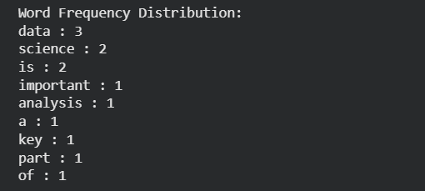
14. Scenario:
You are a data analyst working for a company that sells products online. You have
been tasked with analyzing the sales data for the past month. The data is stored in a Pandas data
frame.
Question:
Develop a code in python to find the frequency distribution of the ages of the customers
who have made a purchase in the past month.
Code:
import pandas as pd
sales_data = pd.DataFrame({
"customer_id": [101, 102, 103, 104, 105, 106],
"age": [25, 30, 25, 35, 30, 40],
"purchase_amount": [500, 700, 300, 900, 650, 800]
})
age_frequency = sales_data["age"].value_counts()
print("Frequency distribution of customer ages:")
print(age_frequency)
Code:
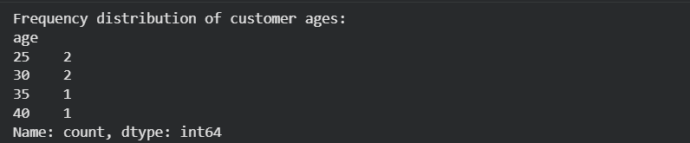
15. Scenario:
You are a data analyst working for a social media platform. As part of your analysis, you have a dataset containing user interaction data, including the number of likes received by each post. Your task is to develop a Python program that calculates the frequency distribution of likes among the posts.
Question:
Develop a Python program to calculate the frequency distribution of likes among the posts?
Code:
import pandas as pd
post_data = pd.DataFrame({
"post_id": [1, 2, 3, 4, 5, 6, 7],
"likes": [10, 25, 10, 40, 25, 10, 50]
})
likes_frequency = post_data["likes"].value_counts()
print("Frequency distribution of likes:")
print(likes_frequency)
Output:
